For the color blindness test, the FMD-15 is used in order to classify the type of color blindness the patient has. This is because it can classify the 3 types of deficiencies and its fast testing time. Using both eyes, the patient is positioned at 50cm from the monitor. The hues are arranged randomly in a line as shown in the test’s user interface in figure 3.2. Based on the figure, the test is administered with black background for maximum contrast in order to avoid wrong perception of color due to surroundings. The test is done by rearranging the colors by hues beside the reference hue. After the submission of the test, the order that the hues are arranged are recorded and compared with the normal order and the confusion axes. Figure 3.3 shows the test result of the patient after submission in the form of the circular results diagrams and diagnosis. The summary of test results for the sample are shown on table 3.2.

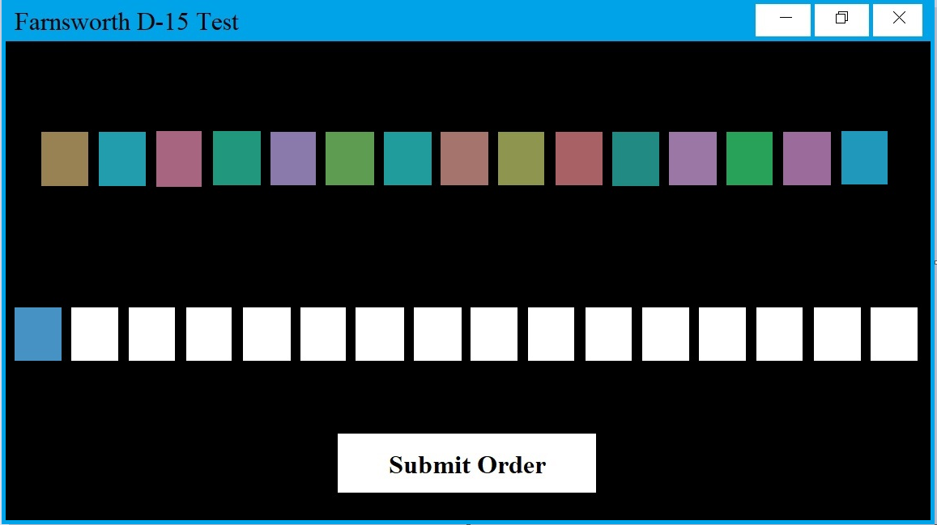

**Figure 3.2:** FMD-15 test user interface

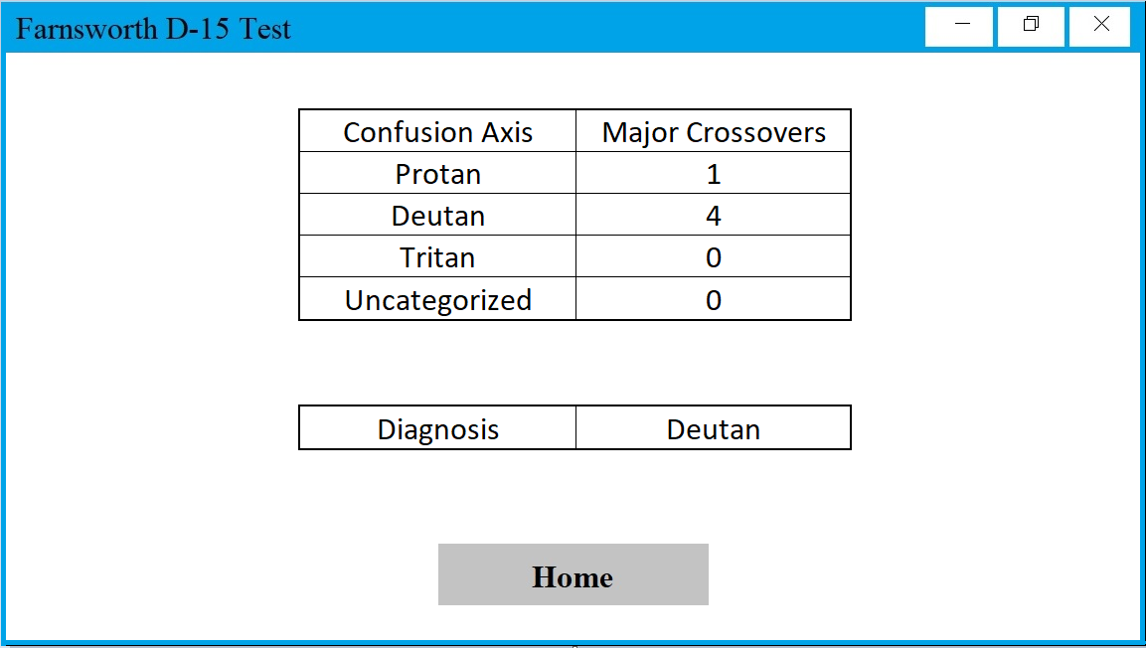

**Figure 3.3:** Color Blindness test result (to be displayed only)

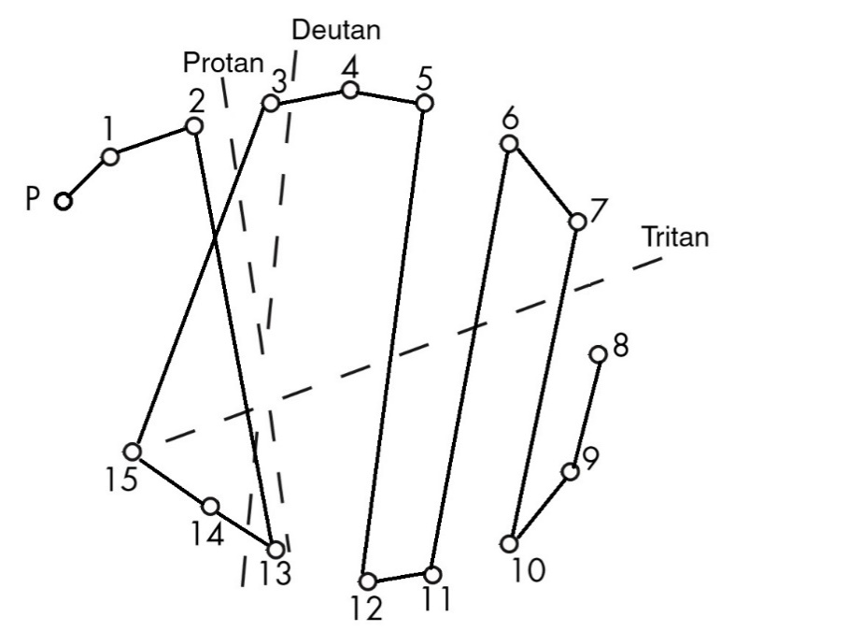

**Figure 3.4:** Color Blindness test result (to be stored in the database only)

**Table 3.2.**

|  |  |  |  |
| --- | --- | --- | --- |
|  |  |  |  |
|  |  |  |  |
|  |  |  |  |
|  |  |  |  |

**Table 3.3.**

Results for color vision test

|  |  |  |  |  |  |  |
| --- | --- | --- | --- | --- | --- | --- |
| Patient number | Trial 1 | Time 1  (min.) | Trial 2 | Time 2  (min.) | Classification | Classification (Ophthalmologist) |
| xxx | Fig CVxxx.1 | 2.3 | Fig CVxxx.2 | 2 | Normal/ Near normal | Near normal |
| 1 |  |  |  |  |  |  |
| 2 |  |  |  |  |  |  |
| 3 |  |  |  |  |  |  |
| 4 |  |  |  |  |  |  |
| 5 |  |  |  |  |  |  |
| 6 |  |  |  |  |  |  |
| 7 |  |  |  |  |  |  |
| 8 |  |  |  |  |  |  |
| 9 |  |  |  |  |  |  |
| 10 |  |  |  |  |  |  |
| 11 |  |  |  |  |  |  |
| 12 |  |  |  |  |  |  |
| 13 |  |  |  |  |  |  |
| 14 |  |  |  |  |  |  |
| 15 |  |  |  |  |  |  |
| 16 |  |  |  |  |  |  |
| 17 |  |  |  |  |  |  |
| 18 |  |  |  |  |  |  |
| 19 |  |  |  |  |  |  |
| 20 |  |  |  |  |  |  |
| 21 |  |  |  |  |  |  |
| 22 |  |  |  |  |  |  |
| 23 |  |  |  |  |  |  |
| 24 |  |  |  |  |  |  |
| 25 |  |  |  |  |  |  |